Project Management
Milestone 01
Group-9

Project Title :- LI-ON Power Pack

Description :- South Australia (SA) suffered a statewide blackout a few years back. The power supply by the Government was not sufficient in order to fulfill the national demand in 2017. As a result, the summer period witnessed power cuts in many regions of SA and hence, there has been an utmost need for resolving such issue as soon as possible. Since the issue is of national Interest, the SA Government has taken this issue quite seriously and hence there have been number of tenders by the private parties and corporate houses for establishment of power generation plants with the public-private partnership (PPP) mode or totally through the privatization mode.
The given project report provides a brief overview of the various aspects of project management of power plant at The Hornsdale Wind Farm at SA.

Team Name:- Saviors

Team Member Names :-
Himaja Parachuri
Raghavendra Reddy
Venkata Gopi Siva Sai Nallapati
SaiKumar Mylavarapu
Nagateja Neerukonda

Client :- Dr. Aziz Fellah
Team Logo:-
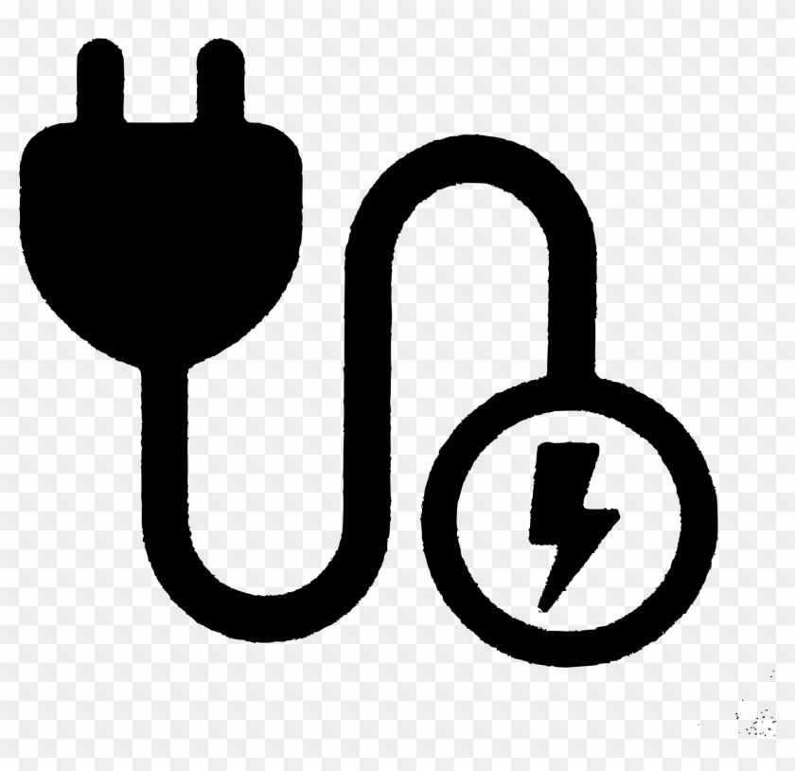

Working as a team together: We will take responsibility as a team to execute the project on schedule and within the budget all with maintaining high quality.
Contacting each other:
We will be communicating using Northwest Email, Zoom , Microsoft Teams for online meetings.
Dealing with a non-participating team member:
We'll check as a group to see if the project is on schedule, and if any team members aren't contributing, we'll try to talk to them about it. We shall assign the work that an individual is interested in, If he or she is not interested in the offered work.

Roles:
Project Manager
- Person responsible for planning
- Organizing
- Managing
- Controlling
- Communicating on all phases of a project
- Assigning Tasks

Resource Manager
- Resource Planning and allocation.
- Capacity Planning.
- Hiring new employees
- Resources and is accountable for the overall delivery of the project

Functional Manager
- Propose projects
- Monitor projects performance
- Demand management
- Those using resources to execute projects
- Supply management
Business Analyst
- The Business Analyst is responsible for investigating business systems
- Identifying options for improving business systems
- Bridging the needs of the business with the use of IT
- Document technical and business requirements

Electrical Engineer
- To design, develop, test, and supervise the manufacturing.
- Electrical components, including electric motors, machinery controls, lighting and wiring, generators, communications systems, and electricity transmission systems.
- They are responsible for developing and implementing systems that use electricity.

Project Charter
Date:5/17/2021

Project Title: LI-ON Power Pack
Project Start Date: 05/17/2021 Projected Finish Date: 06/03/2021
Budget Information: $A200 million - $A240 million
Project Manager: Himaja Parachuri
Phone: 6605280792
E-mail: S542391@nwmissouri.edu
Project Objectives: To provide an output of 100 megawatts of power at a time
To produce enough energy to power about 30,000 homes for more than an hour
To provide emergency backup power if a shortfall in energy is predicted.
Success Criteria: The project goal may be defined to be the creation of battery storage facility for SA region so that the nation does not suffer from a crisis of power cut. In addition, as stated earlier, the project will envisage the utilization and integration of renewable energy for the state.
Approach: We'd like to complete the project on time and on budget using the agile methodology. To make the requirements explicit and avoid ambiguity with the team and the client, daily scrum meetings are organized with the team to have regular interactions.
Roles and Responsibilities
Name and Signature | Role | Position | Contact Information
Himaja Parachuri | Project Manager | Manager | S542391@nwmissouri.edu
Raghavendra Reddy | Resource Manager | Team Lead | S542272@nwmissouri.edu
Venkata Gopi Siva Sai Nallapati | Functional Manager | Team Member | S541996@nwmissouri.edu
SaiKumar Mylavarapu | Business Analyst | Team Member | S542300@nwmissouri.edu
Nagateja Neerukonda | Electrical Engineer | Team Member | S542313@nwmissouri.edu
Comments: (Handwritten or typed comments from above stakeholders, if applicable)

Stakeholder Register for LI-ON Power Pack

Prepared by: Himaja Parachuri Date: 05/17/2021

Name | Position | Internal/External | Project Role | Contact Information
Himaja Parachuri | Manager | Internal | Project Manager | S542391@nwmissouri.edu
Raghavendra Reddy | Team Lead | Internal | Resource Manager | S542272@nwmissouri.edu
Venkata Gopi Siva Sai Nallapati | Team Member | Internal | Functional Manager | S541996@nwmissouri.edu
SaiKumar Mylavarapu | Team Member | Internal | Business Analyst | S542300@nwmissouri.edu
Nagateja Neerukonda | Team Member | Internal | Electrical Engineer | S542313@nwmissouri.edu
Dr. Aziz Fellah | Client | External | End User | afellah@nwmissouri.edu

Signatures:
Himaja Parachuri
Raghavendra Reddy
Venkata Gopi Siva Sai Nallapati
SaiKumar Mylavarapu
Nagateja Neerukonda

